Homework 3
1. TCP (Transmission Control Protocol)
TCP is a connection-oriented transport layer protocol. The goal is to capture the three-way handshake.
Capture Strategy: Start a capture, open a web browser, and type a website URL, then stop.
- In a browser – navigated to www.espn.com
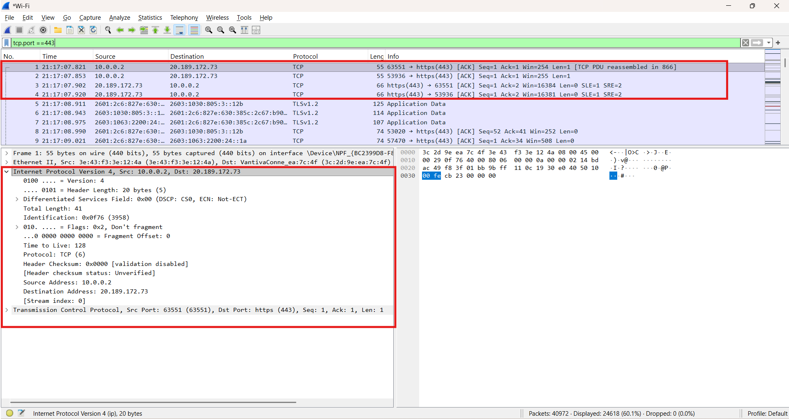
The primary focus of the analysis is to identify and document the TCP Three-Way Handshake, the mechanism by which TCP establishes a reliable, ordered connection prior to the exchange of any application data. This handshake is defined by three critical packets: the initial SYN (Synchronize) packet from the client, the responsive SYN-ACK (Synchronize-Acknowledge) packet from the server, and the final ACK (Acknowledge) packet from the client, which completes the circuit.
In the packet details pane, the report shows key properties that validate the protocol's function, specifically the interplay between the Sequence Number (tcp.seq) and the Acknowledgement Number (tcp.ack). A critical observation is how the Acknowledgement Number in the second and third packets is precisely the previous Sequence Number plus one, confirming the reliable sequencing. Furthermore, the Flags field (e.g., tcp.flags.syn or tcp.flags.ack) must be inspected to ensure the appropriate bit is set to '1' in each packet of the handshake, confirming the control mechanism described in the transport layer specifications.
2. UDP (User Datagram Protocol)
UDP is a connectionless transport layer protocol, often used for DNS, streaming, and gaming where speed is prioritized over guaranteed delivery.
- Capture Strategy: Streamed a video on www.youtube.com
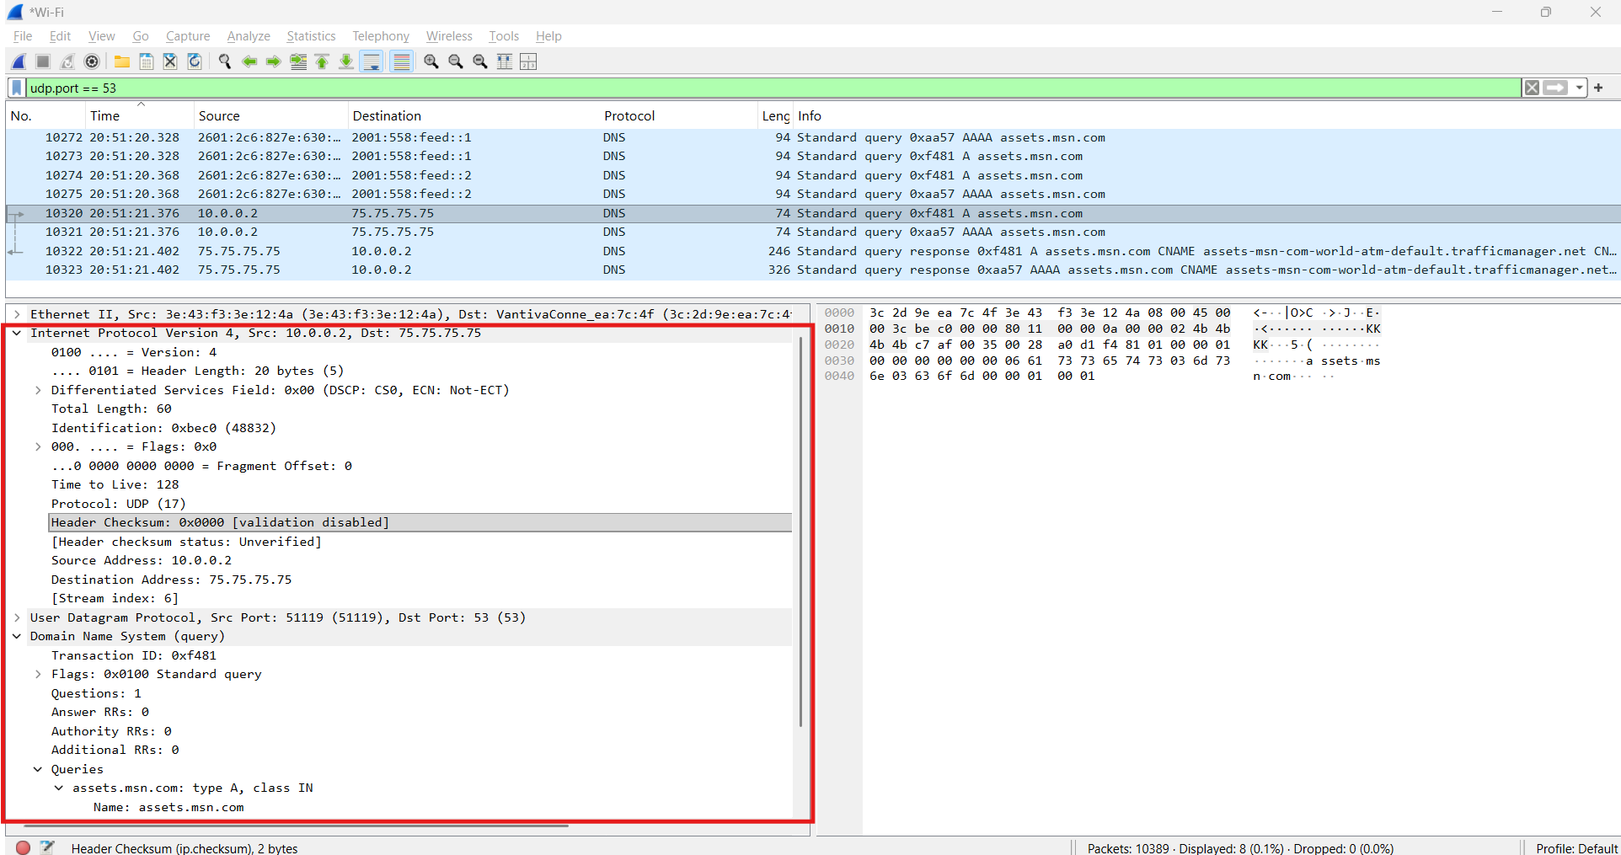
The analysis of User Datagram Protocol (UDP) traffic centers on observing its connectionless operational model, typically involving a direct exchange between a single outbound query packet and an inbound response packet. The core purpose of UDP is to facilitate the rapid transmission of data, such as Domain Name System (DNS) requests, by consciously eliminating the overhead required for a connection handshake. This efficiency, however, is coupled with the protocol's inherent unreliability. Key properties to visualize in the packet details pane include the minimal header structure, consisting only of the Source Port, Destination Port, Length, and Checksum. Crucially, observation of the packet flow reveals the lack of any SYN/ACK connection establishment and no subsequent acknowledgement of the received data, which fundamentally demonstrates UDP's datagram-oriented, best-effort delivery mechanism.

3. IPv4 (Internet Protocol v4)
IPv4 is the dominant network layer protocol, responsible for logical addressing and routing.
- Capture Strategy: Simply load any public webpage.
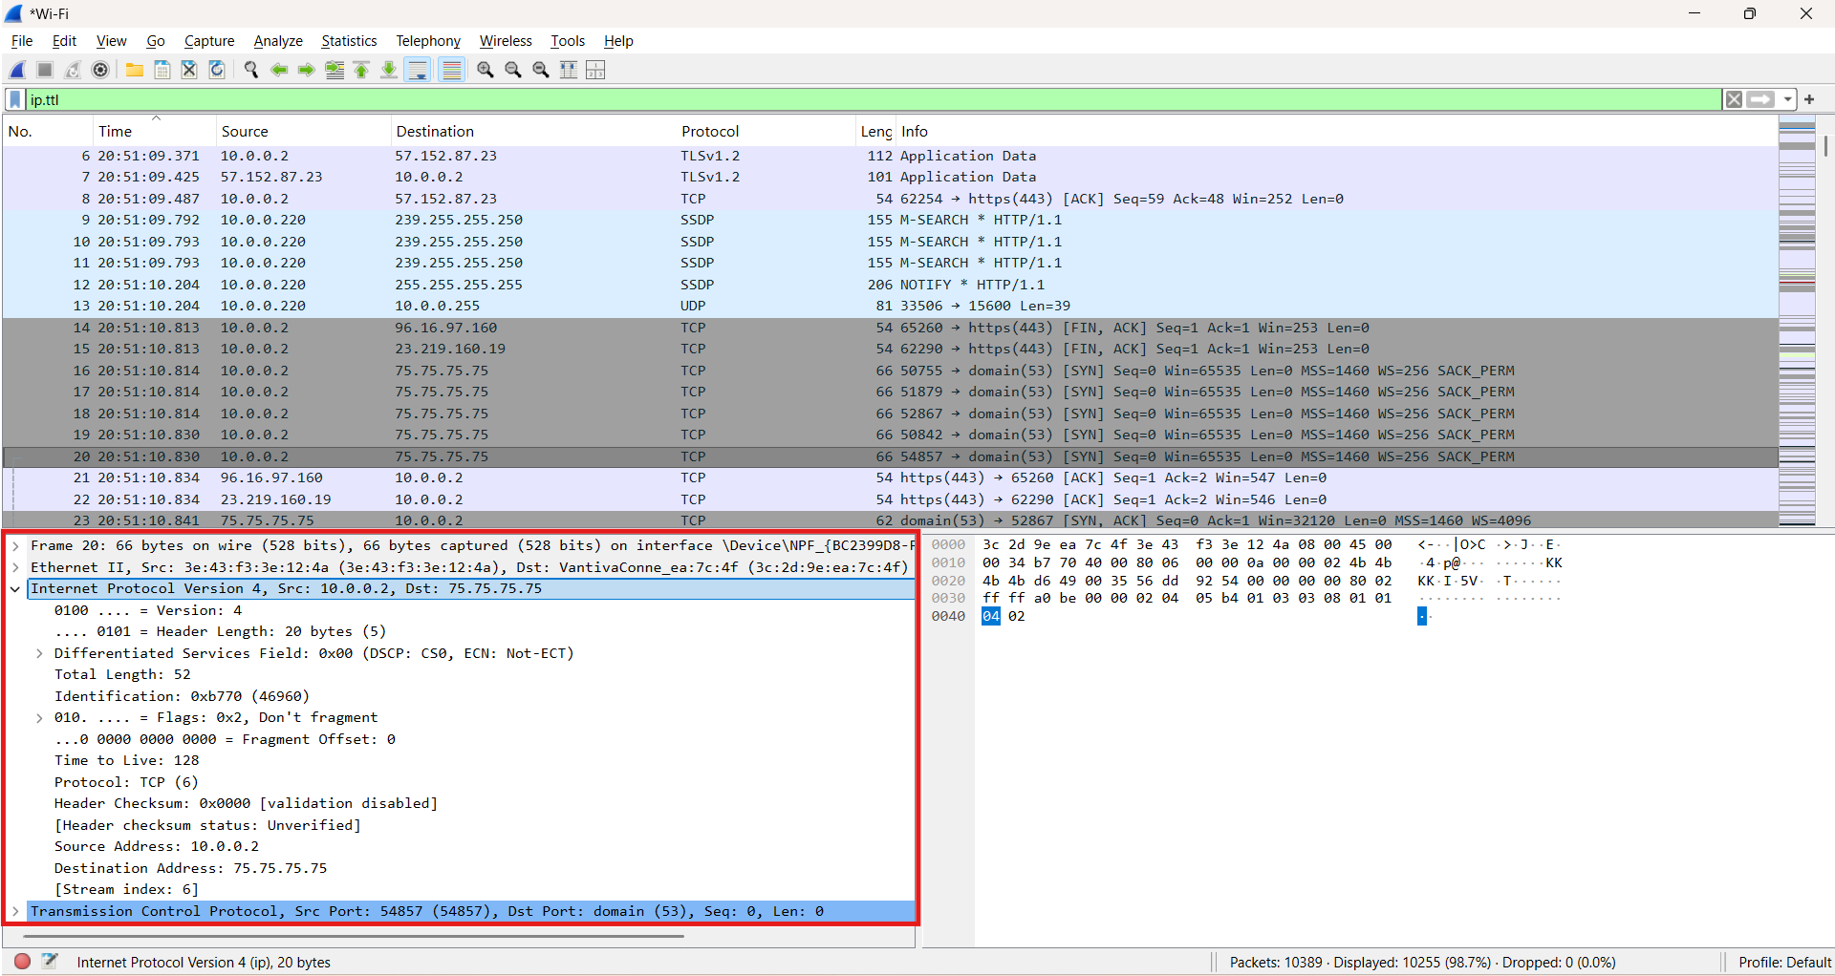
The focus of the analysis for Internet Protocol version 4 (IPv4) involves examining nearly any captured packet, as virtually all internet communication relies on this network layer protocol. The core purpose of IPv4 is the encapsulation of transport layer segments and the assignment of a globally unique address—the Source IP and Destination IP—which is essential for routing packets across disparate networks. In the Wireshark packet details, several properties must be visualized. First, the explicit values of the Source Address (ip.src) and Destination Address (ip.dst) fields clearly define the end-to-end communication path. Second, the Protocol field (ip.proto) within the IPv4 header is critical as it identifies the encapsulated transport layer protocol (e.g., '6' for TCP or '17' for UDP), thus illustrating the layer-three to layer-four handoff. Finally, the Time to Live (TTL) field (ip.ttl) requires close observation, as its decrementing value with each router hop provides tangible evidence of the packet's journey and aligns directly with the hop-count limiting mechanism discussed in networking theory.

4. ARP (Address Resolution Protocol)
ARP is a crucial link layer protocol that maps an IP address to a MAC address on the local network.
- Capture Strategy: Use ping to send a single packet to an inactive or new local IP address, or use the arp -d command to clear your local ARP cache and then ping your router.
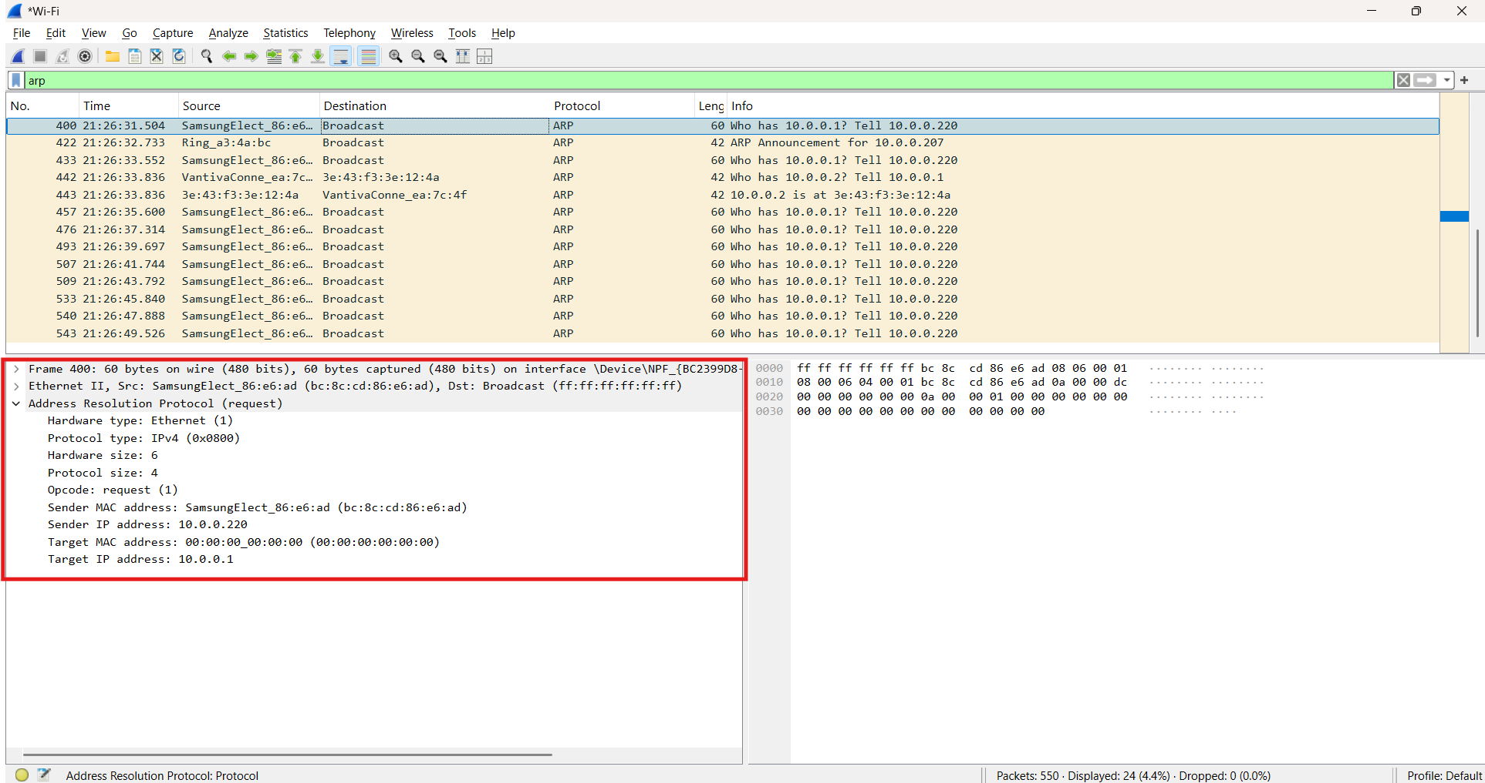
The focus for analyzing the Address Resolution Protocol (ARP) centers on the dynamic mapping process between a known IP address and its corresponding Hardware/MAC address on a local network segment. The protocol's functionality is distinctly observed through two key packets: the ARP Request and the ARP Reply. The ARP Request packet is a crucial finding, characterized by an Opcode set to '1', indicating a request for information. Furthermore, this request packet uses a broadcast physical address (ff:ff:ff:ff:ff:ff) as its Destination MAC Address, as the sender does not yet know the recipient's MAC address, and the "Target MAC address" field will be initialized to all zeros. Conversely, the ARP Reply packet signifies the successful resolution, featuring an Opcode of '2' and acting as a unicast response directly to the requesting device, with the "Target MAC address" field accurately populated with the discovered hardware address of the intended recipient.

5. ICMP (Internet Control Message Protocol)
ICMP is a network layer protocol used for error reporting and network diagnostics (like the ping command).
- Capture Strategy: Run the command ping google.com (or any external IP) in your terminal.
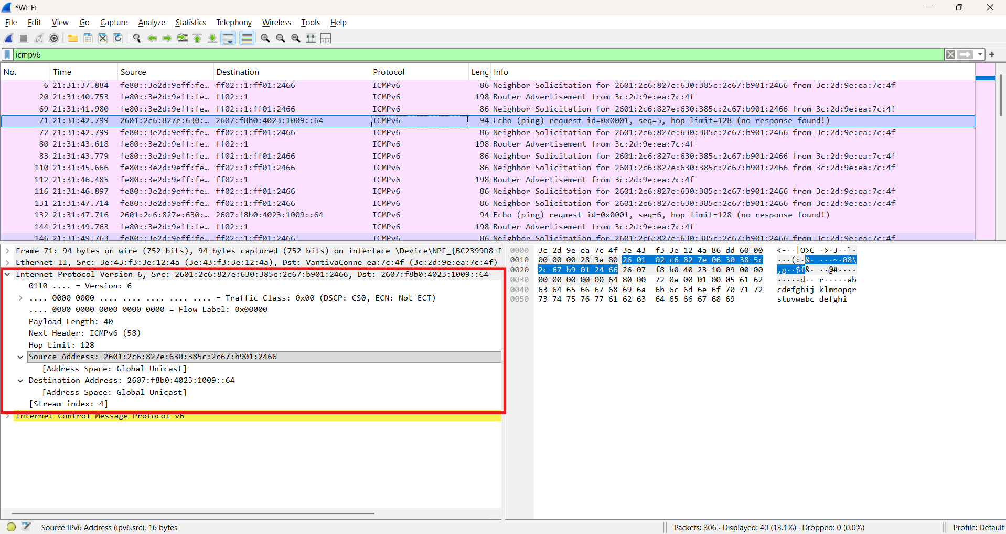
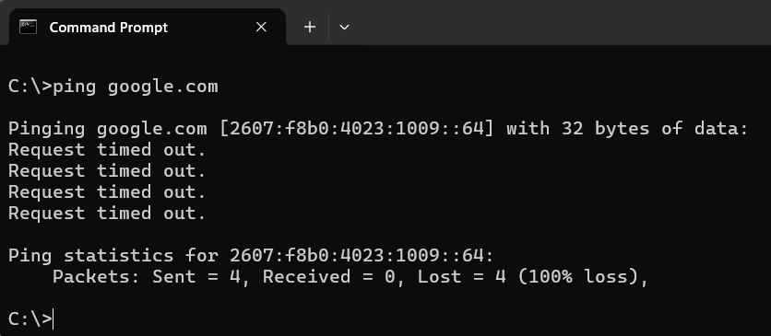
The analysis of Internet Control Message Protocol (ICMP) focuses on its diagnostic utility, which is primarily demonstrated by the exchange of the Echo Request and Echo Reply packets. The fundamental purpose of this exchange is to test reachability between two network devices and to report various network issues back to the source. In Wireshark, the critical fields for visualization are found within the ICMP header itself, particularly the Type field: a value of Type 8 identifies the outbound Echo Request, while Type 0 signifies the inbound Echo Reply. Furthermore, the report should observe the Identifier and Sequence Number fields, which are designed to remain consistent across the request-reply pair, enabling the originating host to reliably associate each reply with its corresponding request. The expected pattern is a one-to-one mapping of request to reply; however, observing deviations from this pattern, such as missing replies or the presence of error messages like "Destination Unreachable," provides highly valuable insights into current network operational issues and should be highlighted in the report.

